ARTIFICIAL INTELLIGENCE
LABORATORY
(CS325)

Bachelor of Technology (CSE)
By
Dhaval Fatnani (20124071)
Third Year, Semester 6



Department of Computer Science and Engineering
School Engineering and Technology
Navrachana University, Vadodara
Spring Semester
PROBLEM DEFINITION: LAND TRADING APPLICATION
Program:
# LAND TRADING APPLICATION
def display_details():
print("Before Transaction")
print("******************************************************************")
print("OWNER 1:")
print("LAND OWNER ID: ", Owner1.land_owner_id)
print("Land Owner Name: ", Owner1.land_owner_name)
print("Land in Acres: ", Owner1.acres_of_land)
print("Amount: ", Owner1.amount)
print("------------------------------------------------------------------")
print("Owner 2:")
print("LAND OWNER ID: ", Owner2.land_owner_id)
print("Land Owner Name: ", Owner2.land_owner_name)
print("Land in Acres: ", Owner2.acres_of_land)
print("Amount: ", Owner2.amount)
print("******************************************************************")
class TradeLand:
def __init__(self, land_owner_id=0, land_owner_name="", acres_of_land=0, amt=0):
self.land_owner_id = land_owner_id
self.land_owner_name = land_owner_name
self.acres_of_land = acres_of_land
self.amount = amt
def get_land_owner_id(self):
return self.land_owner_id
def set_land_owner_id(self, land_owner_id):
self.land_owner_id = land_owner_id
def get_land_owner_name(self):
return self.land_owner_name
def set_land_owner_name(self, land_owner_name):
self.land_owner_name = land_owner_name
def get_acres_of_land(self):
return self.acres_of_land
def set_acres_of_land(self, acres):
self.acres_of_land = acres
def get_amount(self):
return self.amount
def set_amount(self, amt):
self.amount = amt
def sell_land_to(self, quantity_of_land, price_per_acre, selling_to):
if self.acres_of_land < quantity_of_land:
print("Owner Doesn't have that much Land to sell")
elif Owner2.amount < quantity_of_land * price_per_acre:
print("Owner Doesn't have enough money")
else:
self.acres_of_land -= quantity_of_land
selling_to.acres_of_land += quantity_of_land
self.amount += quantity_of_land * price_per_acre
selling_to.amount -= quantity_of_land * price_per_acre
display_details()
# driver code
if __name__ == "__main__":
print("For Owner 1:")
owner_id = int(input("Enter Land Owner ID:"))
name = input("Enter Land Owner Name:")
land_in_acres = int(input("Enter the Land in Acres:"))
amount = int(input("Enter Amount:"))
Owner1 = TradeLand(owner_id, name, land_in_acres, amount)
Owner2 = TradeLand()
print("For Owner2:")
Owner2.set_land_owner_id(int(input("Enter Land Owner ID:")))
Owner2.set_land_owner_name(input("Enter Land Owner Name:"))
Owner2.set_acres_of_land(int(input("Enter the Land in Acres:")))
Owner2.set_amount(int(input("Enter Amount:")))
# DETAILS BEFORE TRANSACTION
display_details()
who_is_selling = int(input("who wants to sell to whom? 1 for Owner1 and 2 for owner2: "))
how_much = int(input("How much land is being sold: "))
price_for_each_acre = int(input("What is the price per acre: "))
if who_is_selling == 1:
Owner1.sell_land_to(how_much, price_for_each_acre, Owner2)
else:
Owner2.sell_land_to(how_much, price_for_each_acre, Owner1)

OUTPUT 1:
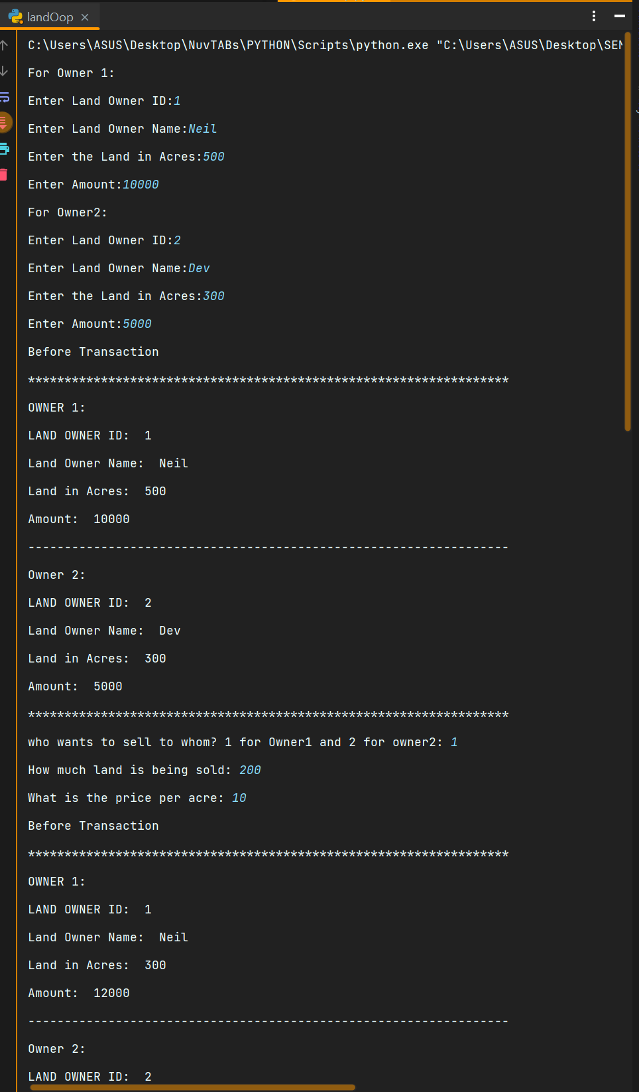
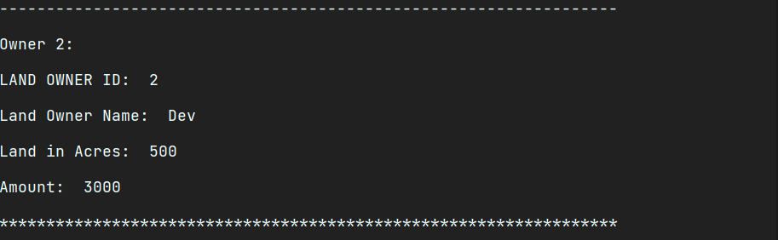
OUTPUT 2:
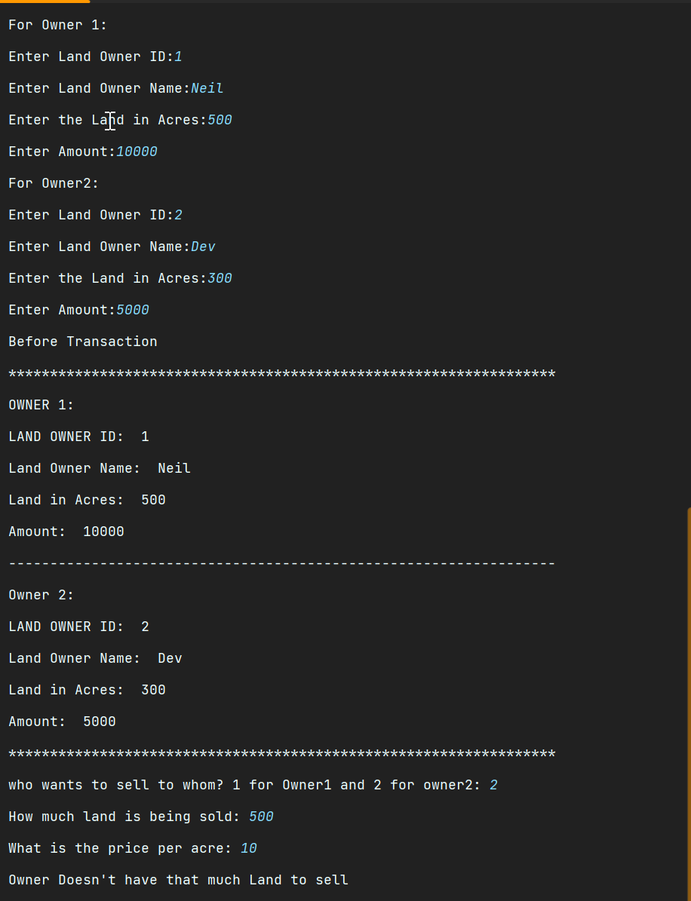
OUTPUT 3:
